Republic of the Philippines

National Police Commission

Philippine National Police

**Cavite Police Provincial Office**

**CARMONA MUNICIPAL POLICE STATION**

Brgy Maduya, Carmona, Cavite

***carmonacavitepnp@gmail.com***

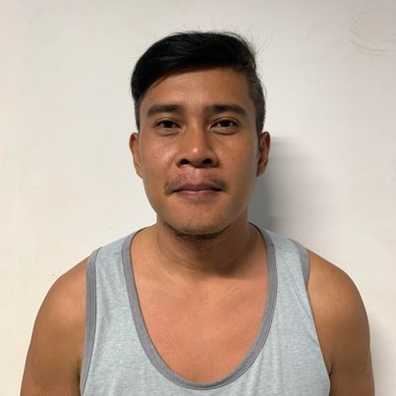

April 5, 2022

**CERTIFICATE OF DETENTION**

**TO WHOM IT MAY CONCERN**

**THIS IS TO CERTIFY** that one **RAY RYAN JAN TAN HERNANDEZ**, male, 36 years old, born on **September 7, 1985**, married, resident of **B3 L48 Longbeach Drive Camella Homes RV1, Tunasan, Muntinlupa City** was detained at this office since April 2, 2022 up to present and charged for the crime of **“Estafa”** with Docketed No.: **IV-03-INQ-22D-1473,** before the Office of Provincial Prosecutor, Imus, Cavite.

This certification is being issued upon request of interested party for whatever legal purposes it may serve.

Prepared by :

Ray Ryan Jan Hernandez, **PSSg Anderson A Videña**

Detainee Custodial Officer